**Garage Management system**

**College Name: GOVERNMENT ARTS AND SCIENCES – GUDALUR**

**College Code: bru4w**

TEAM ID: NM2025TMID22008

TEAM MEMBERS:

Team Leader Name: ARVIND V

Email: varvindarvind2005@gmail.com

Team Member 1: HARIKIRUBAN.K

Email: kirubanhari@gmail.com

Team Member 2: HARIRAM

Email: hr5478848@gmail.com

Team Member 3: NITHEESH C

Email: nitheesh9484@gmail.com

1.INTRODUCTION

1.1 Project Overview

A garage management system centralizes workshop operations—enabling seamless booking, customer relations, job assignments, inventory tracking, invoicing, feedback collection, and insight-driven reporting in a unified platform.

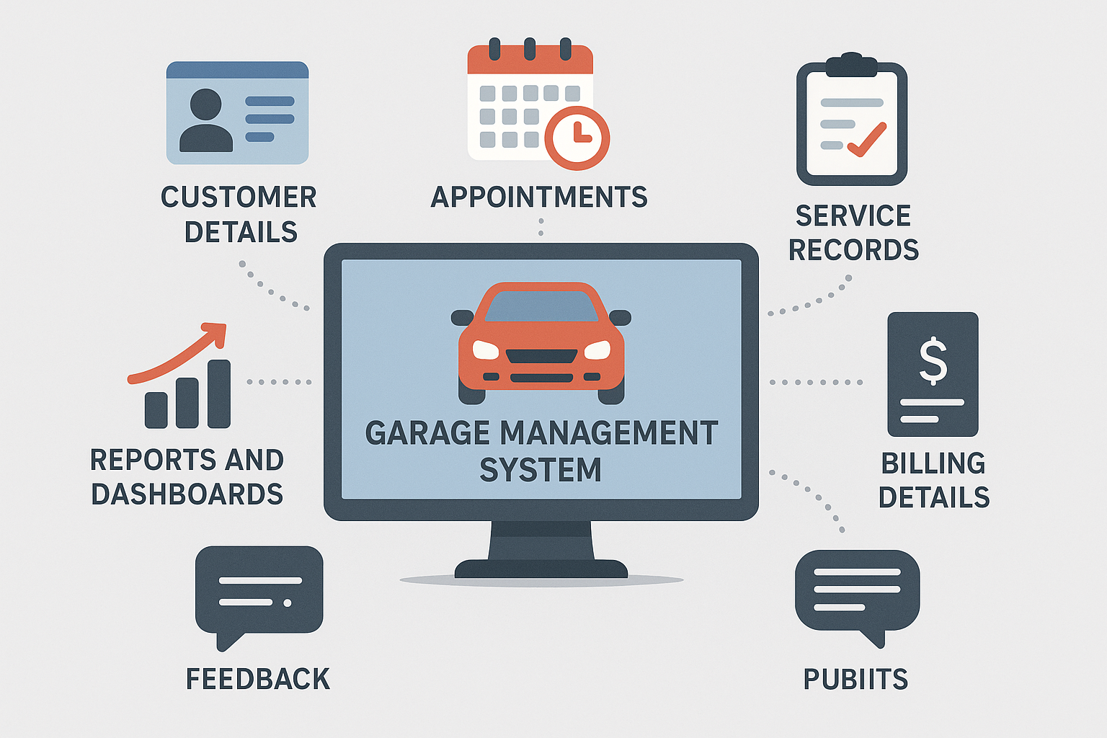

**1.2 Purpose**

The purpose of the Garage Management System is to streamline and automate the operations of a garage, including customer management, appointment scheduling, service tracking, billing, feedback collection, and reporting. This system reduces manual work, minimizes errors, and ensures efficient handling of garage services. It also provides better visibility into business performance through reports and dashboards, ultimately improving customer satisfaction and operational efficiency.

**DEVELOPMENT PHASE**

**Creating Developer Account:**

By using this ORG: <https://www.salesforce.com/form/developer-signup/?d=pb>

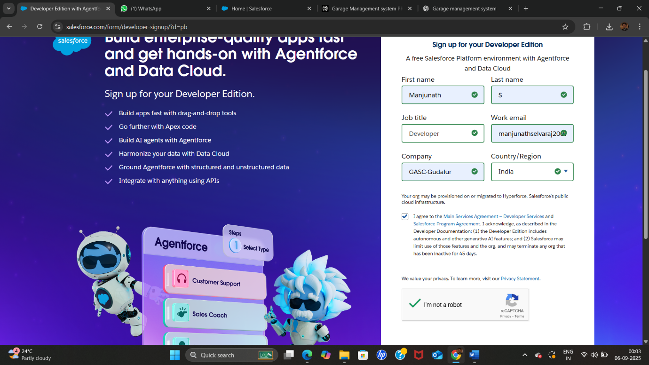

By login ORG: <https://orgfarm-c073410f07-dev-ed.develop.lightning.force.com>

● Created objects: Customer Details, Appointments, Service records, Billing details and feedback

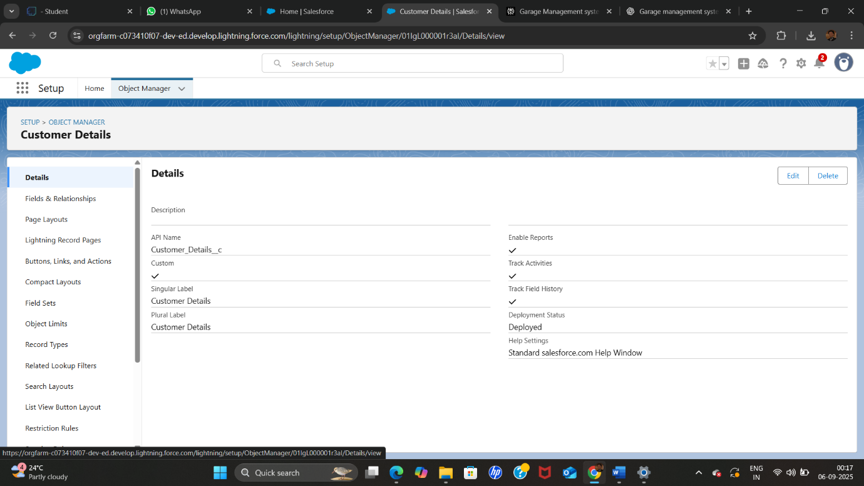

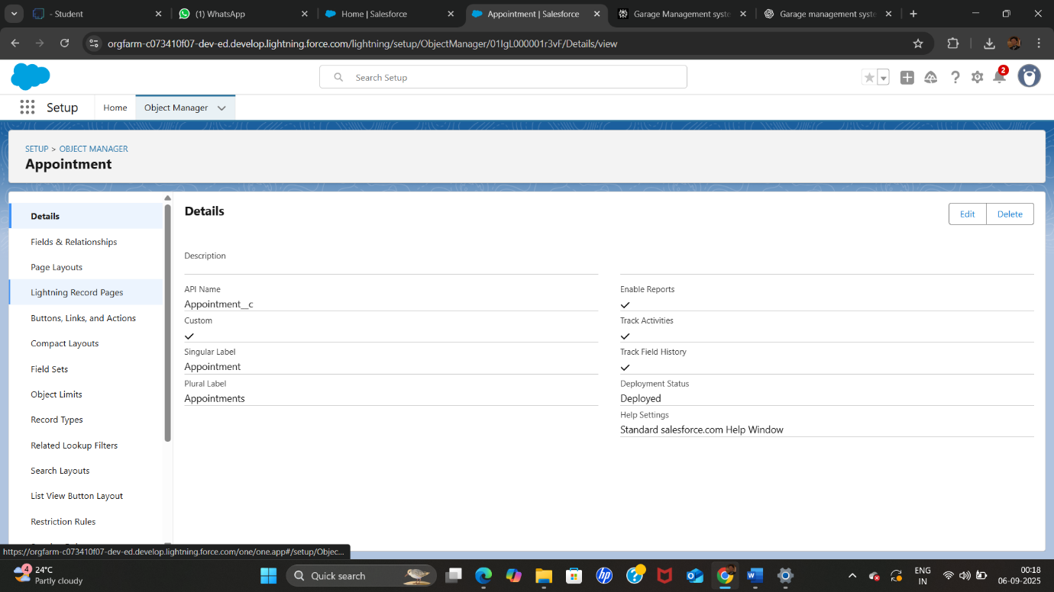

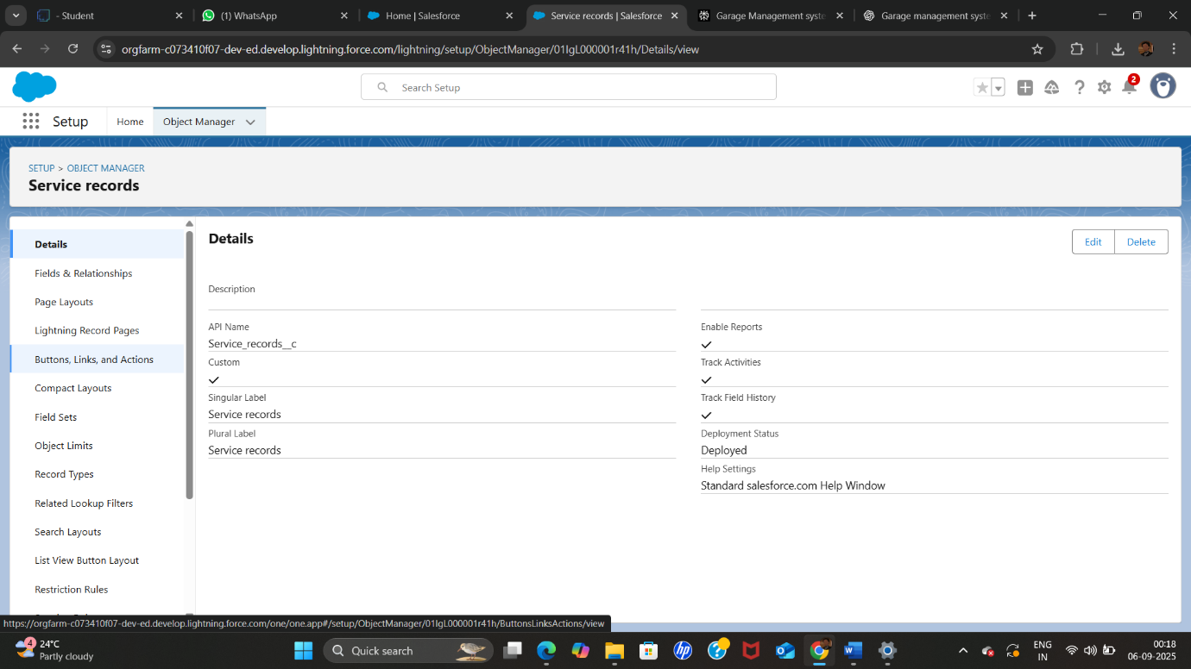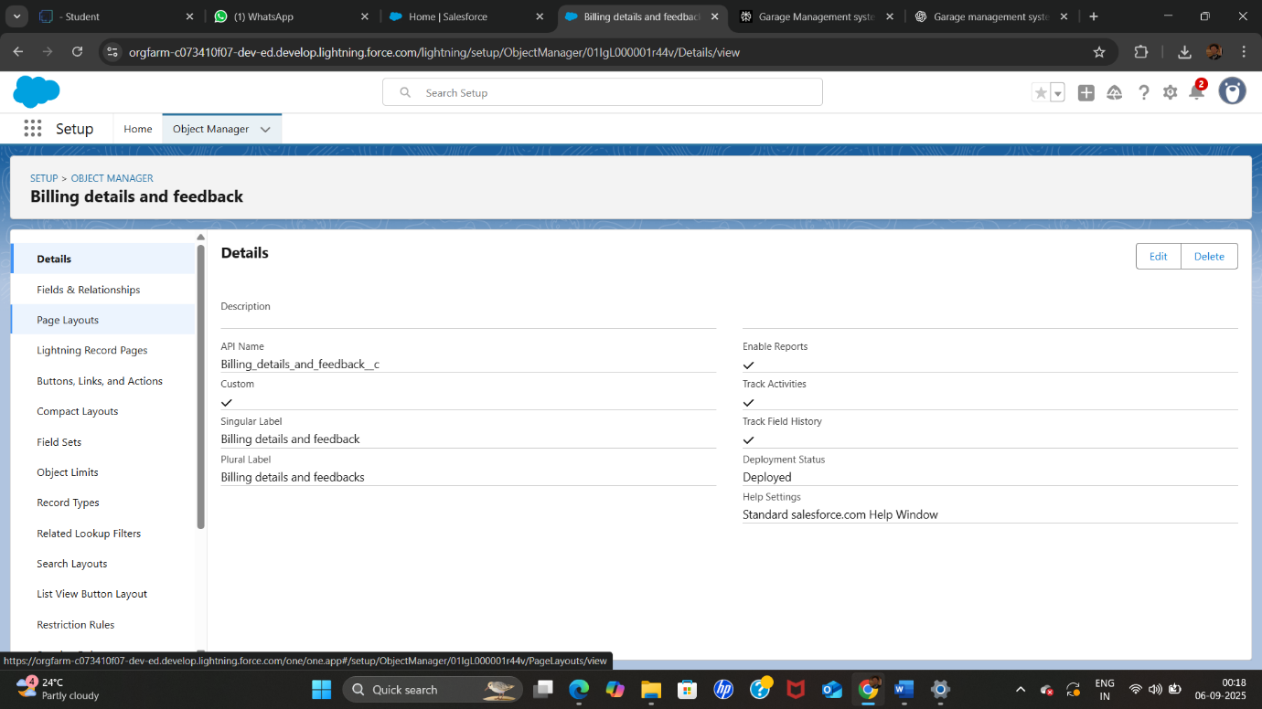

● Creating a Custom Tab

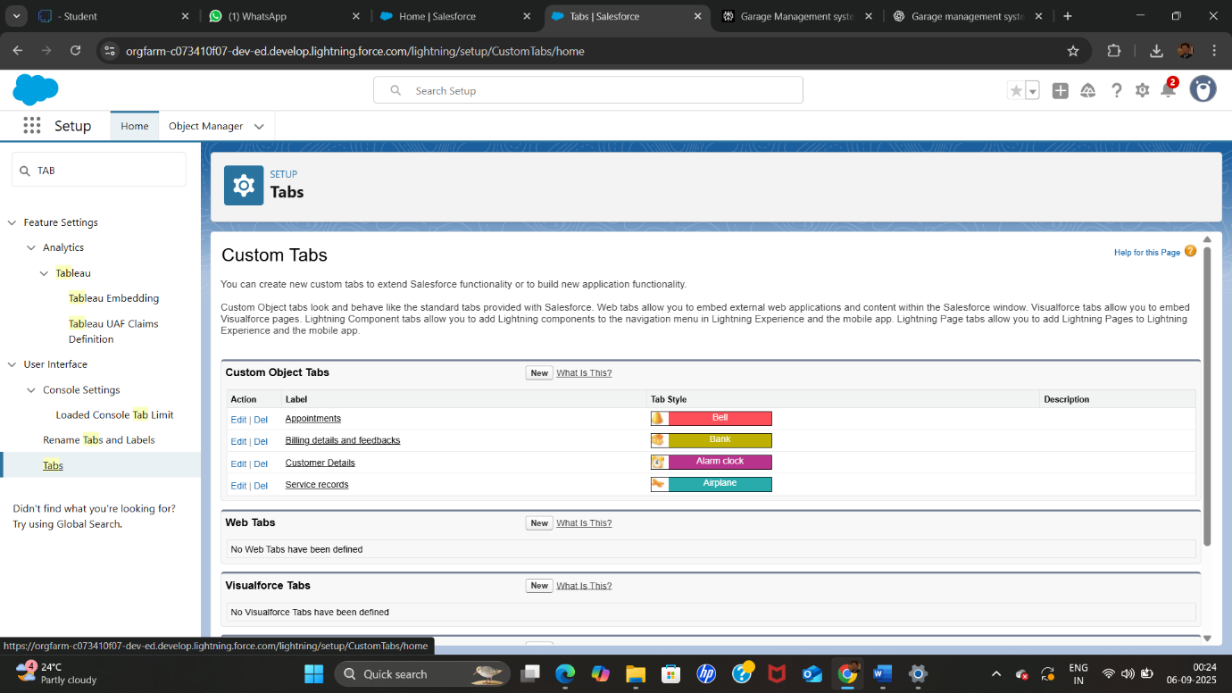

● Developed Lightning App with relevant tabs

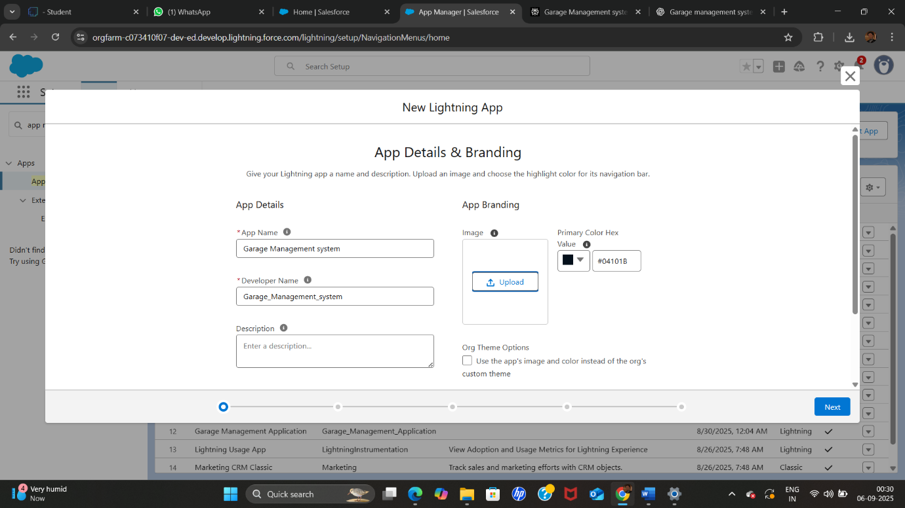

● Configured fields and relationships

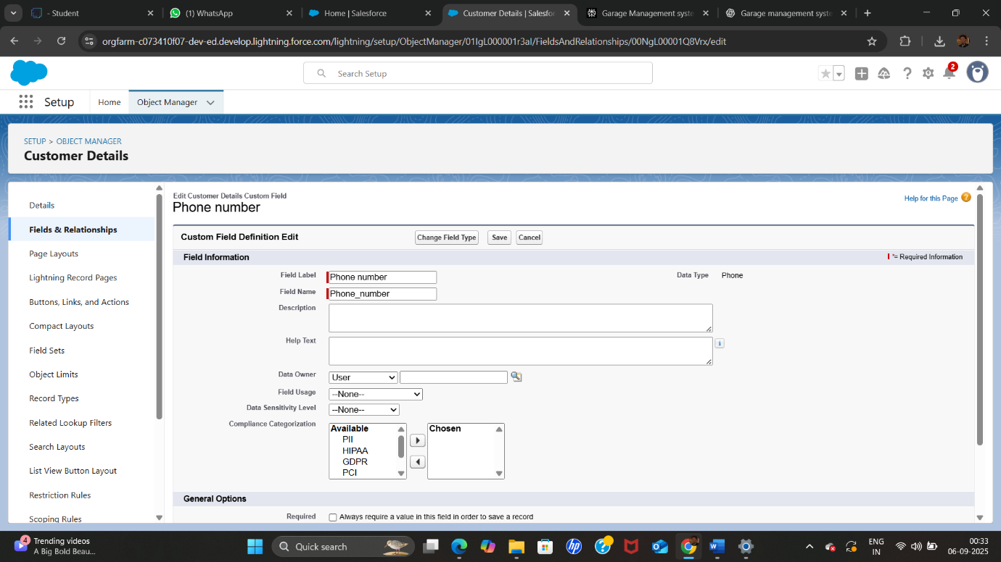

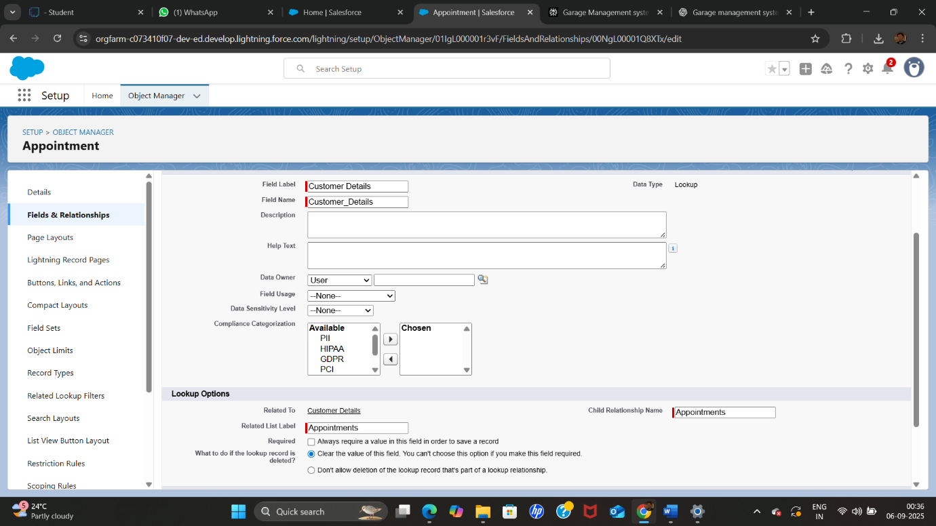

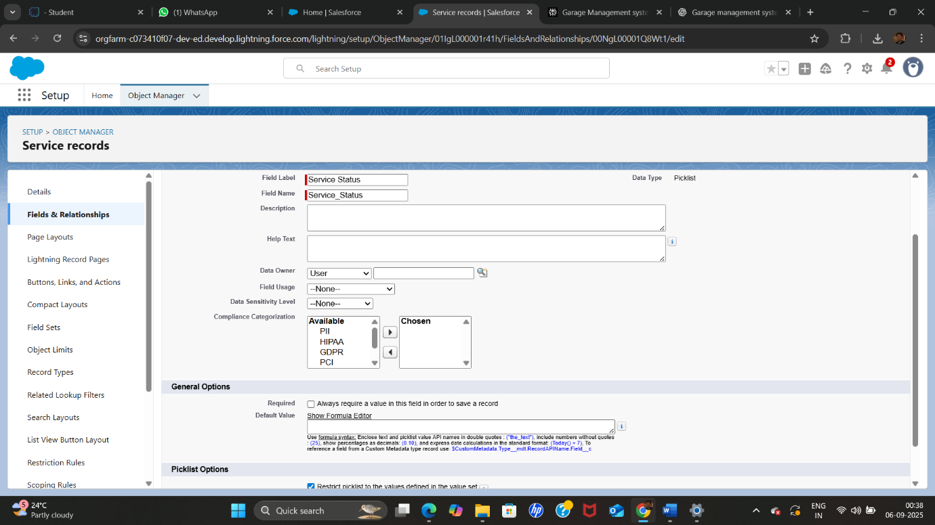

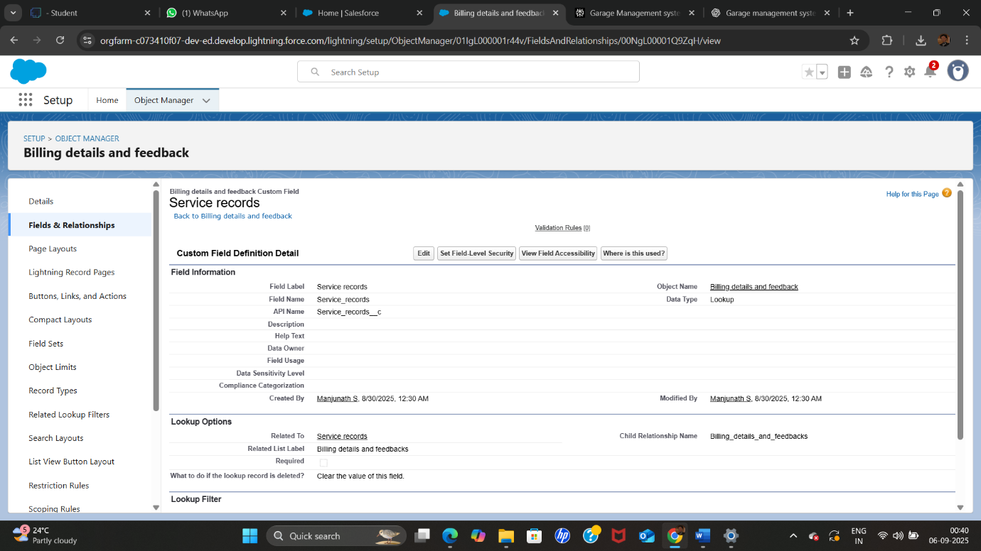

● To create a validation rule to an Appointment Object

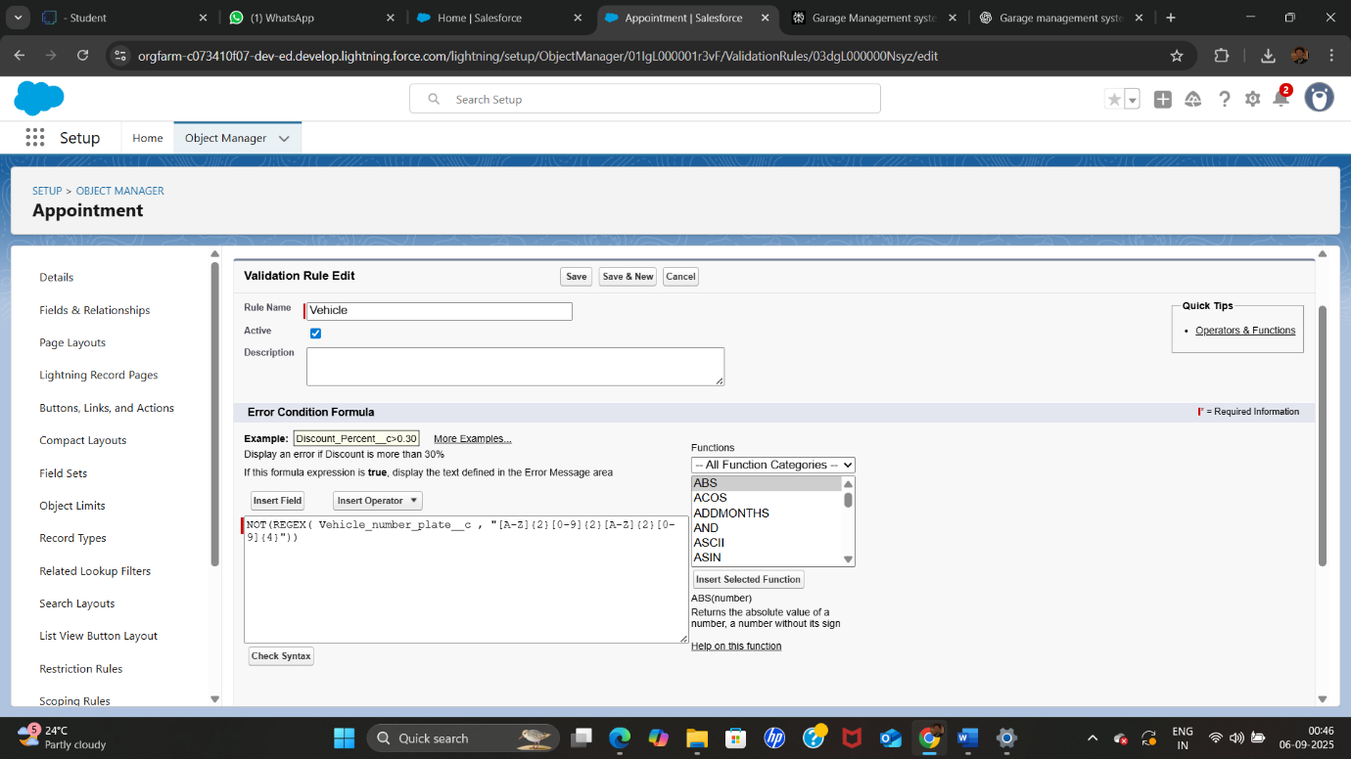

●To create a validation rule to an Billing details and feedback Object

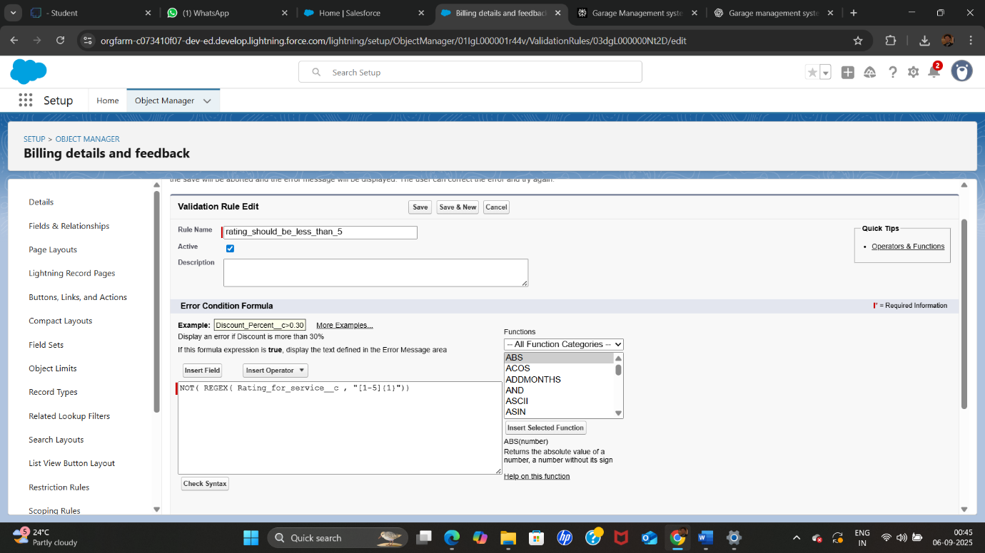

●To create a matching rule to an Customer details Object

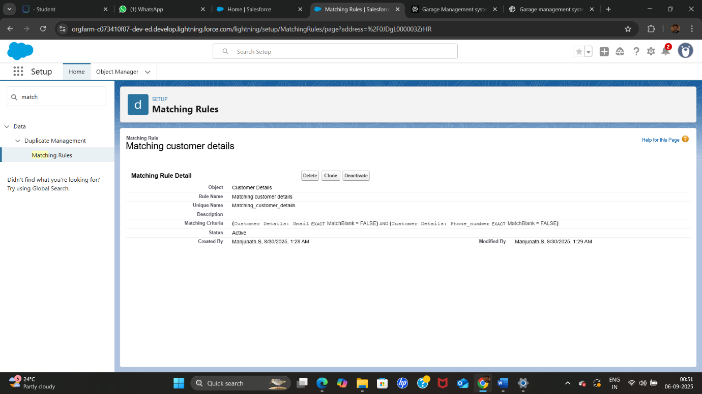

●To create a Duplicate rule to an Customer details Object

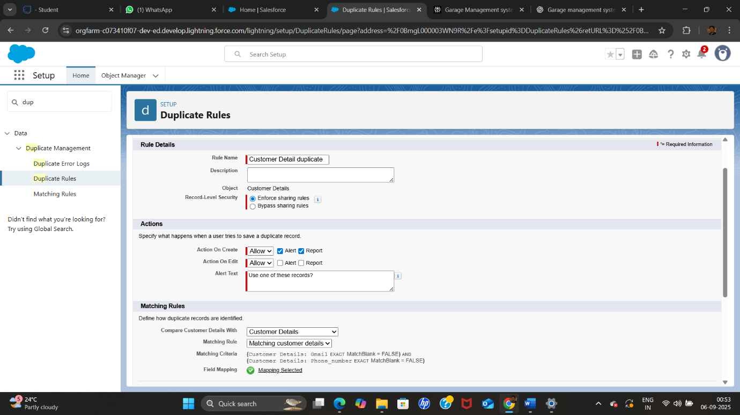

● To create a new profile:

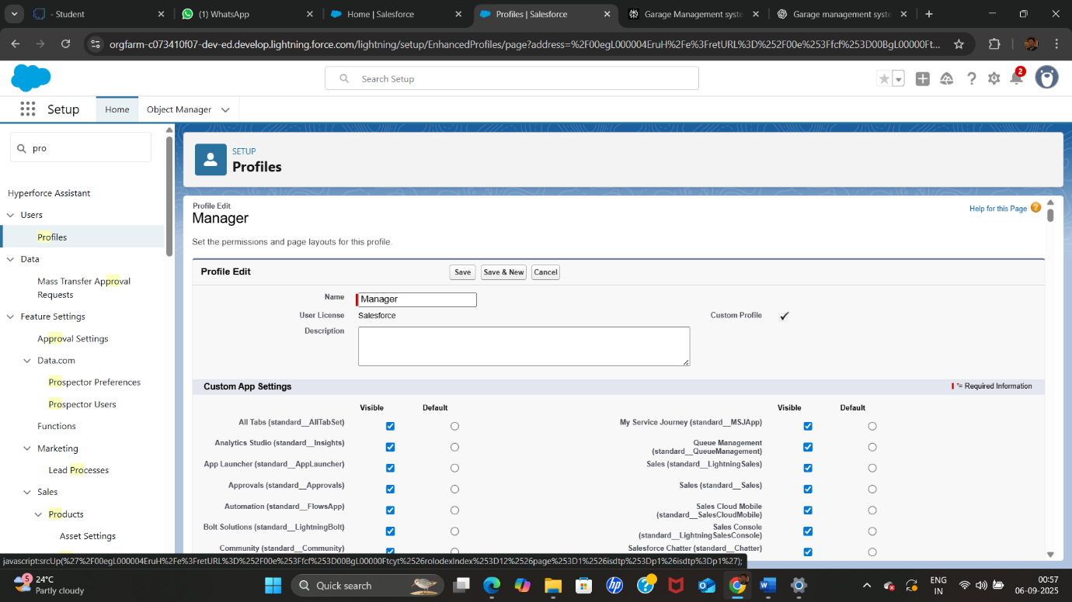

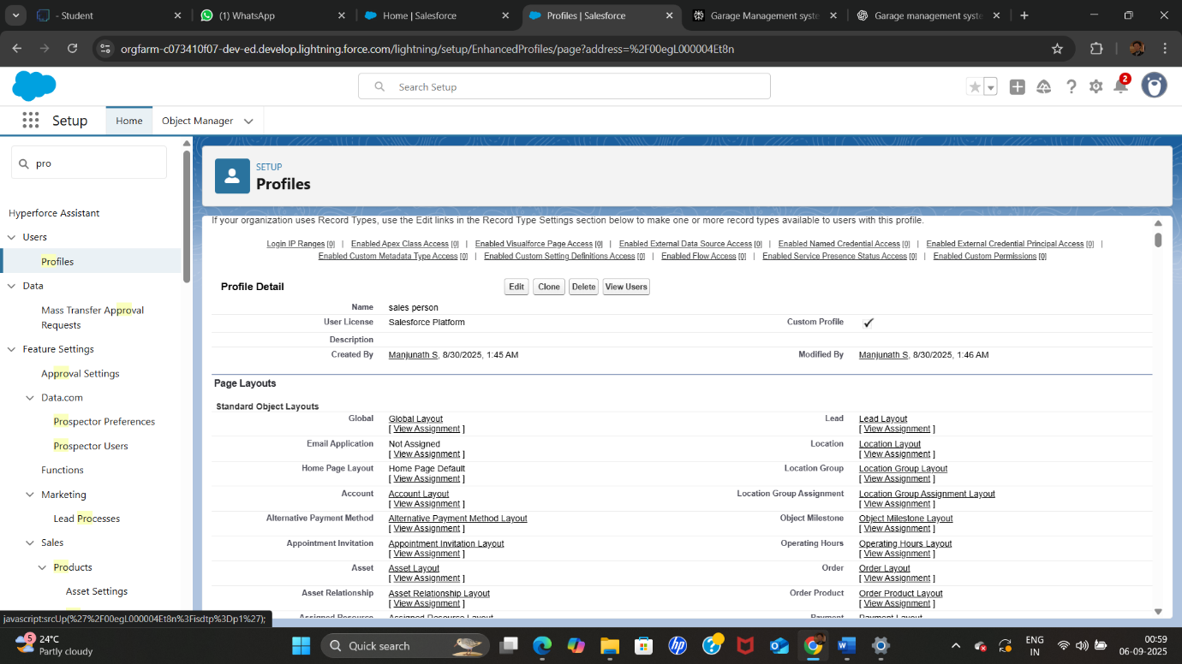

● Role & Role Hierarchy

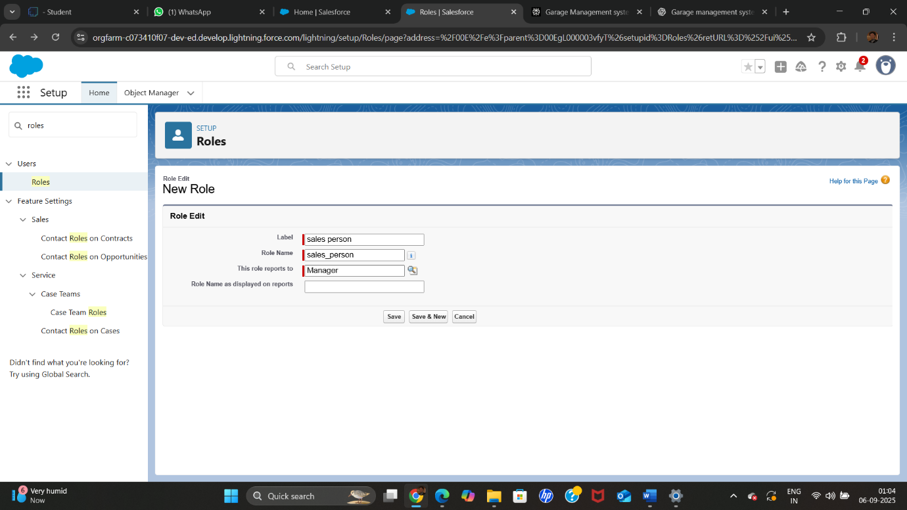

●Create User

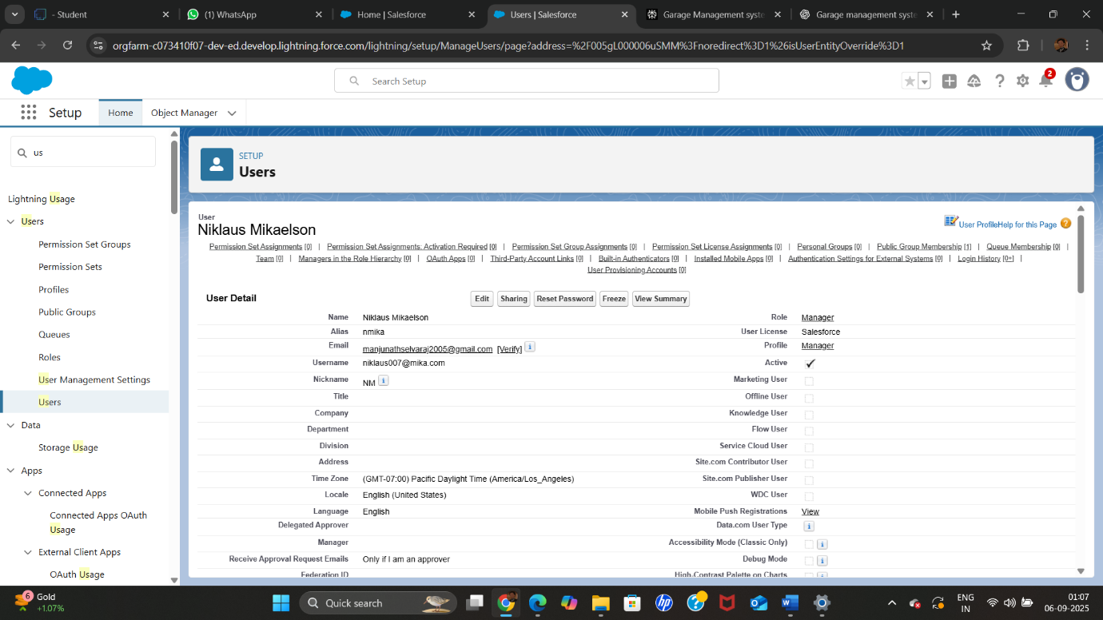

●Creating New Public Group

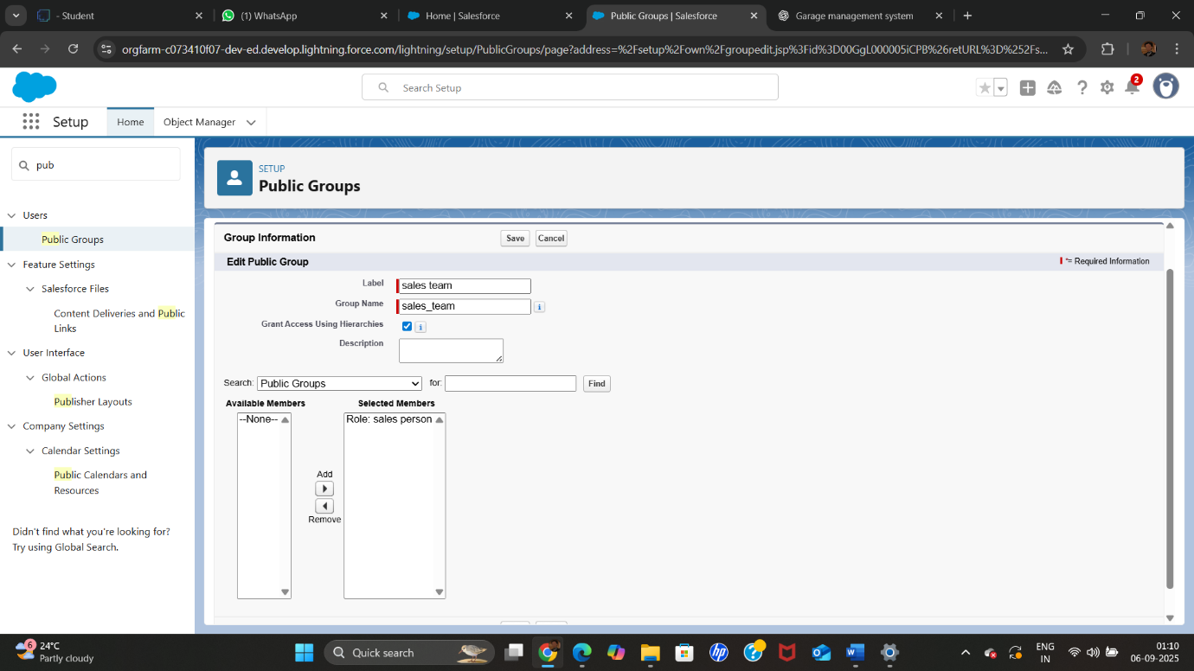

●Creating Sharing settings

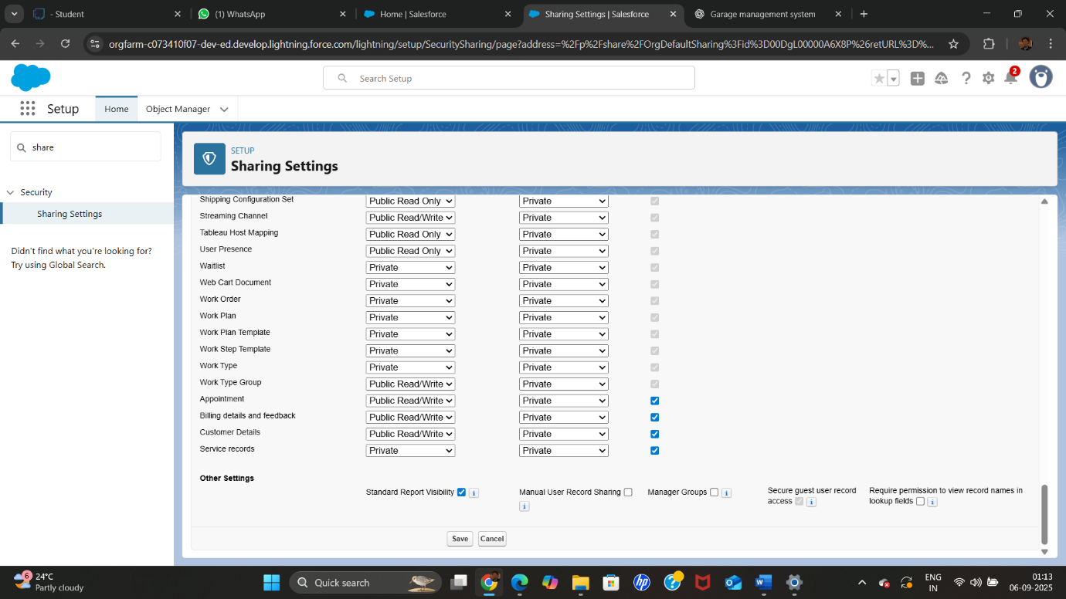

●Create a Flow

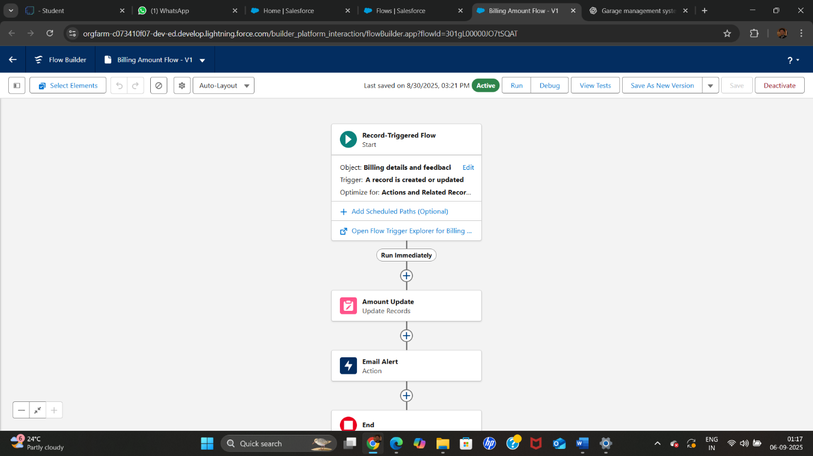

● Apex Trigger

Apex handler

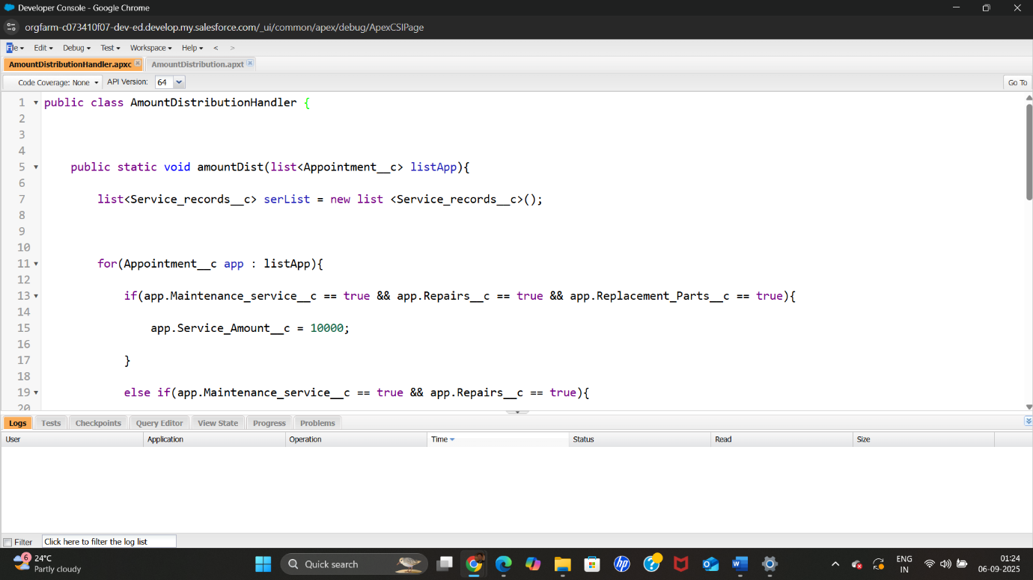

●create a report folder

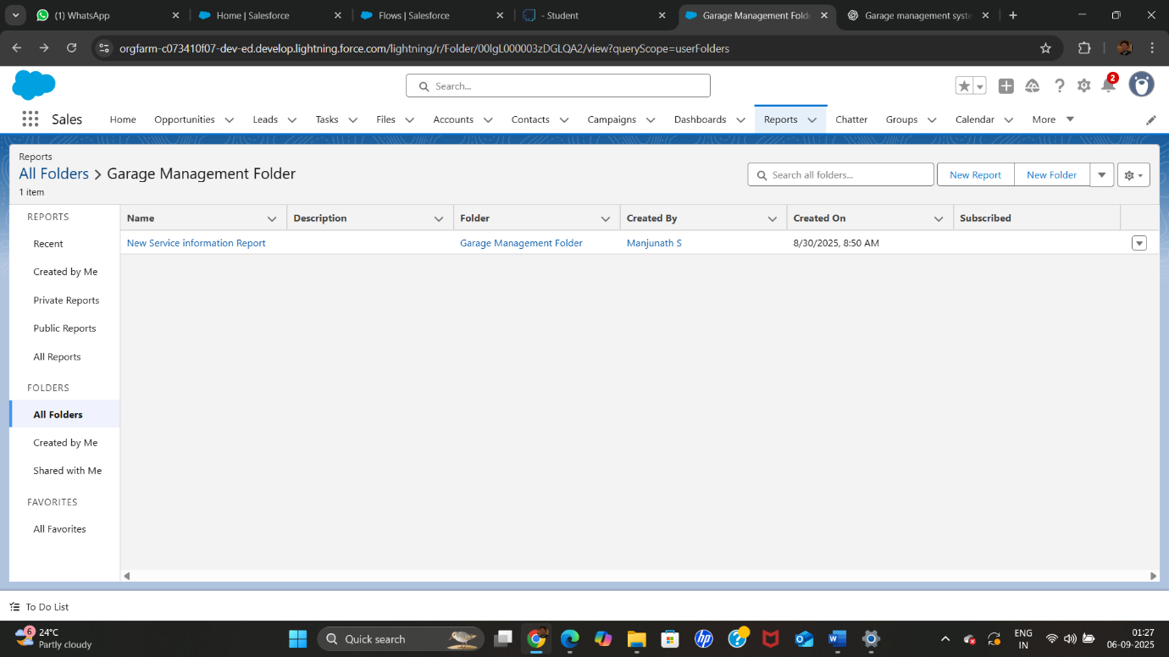

●Create Report Type

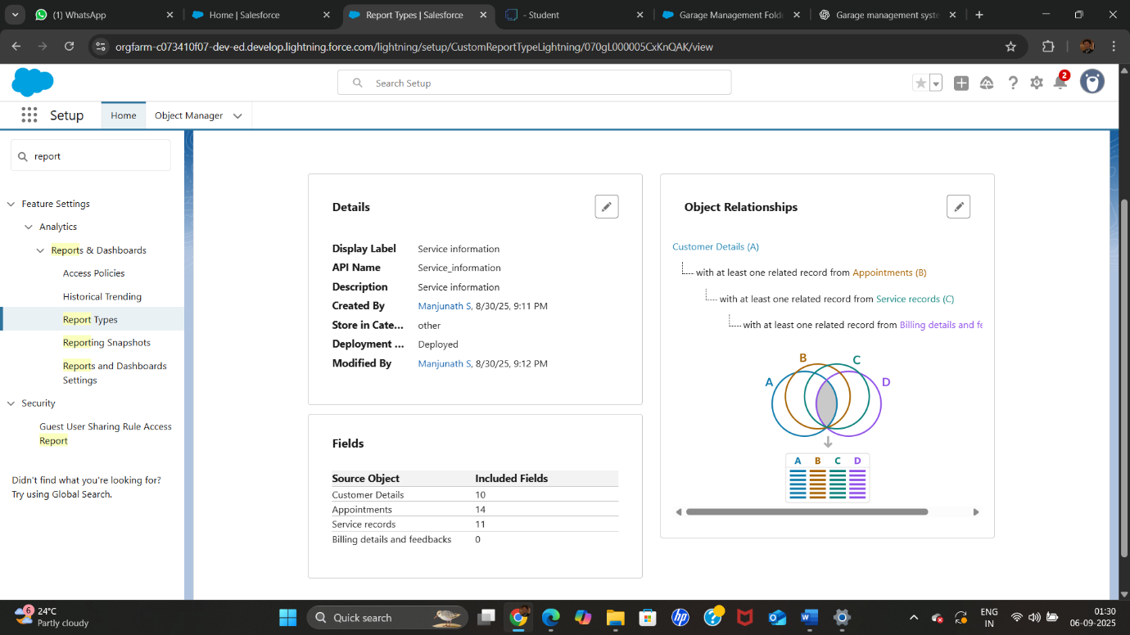

●Create Dashboard Folder

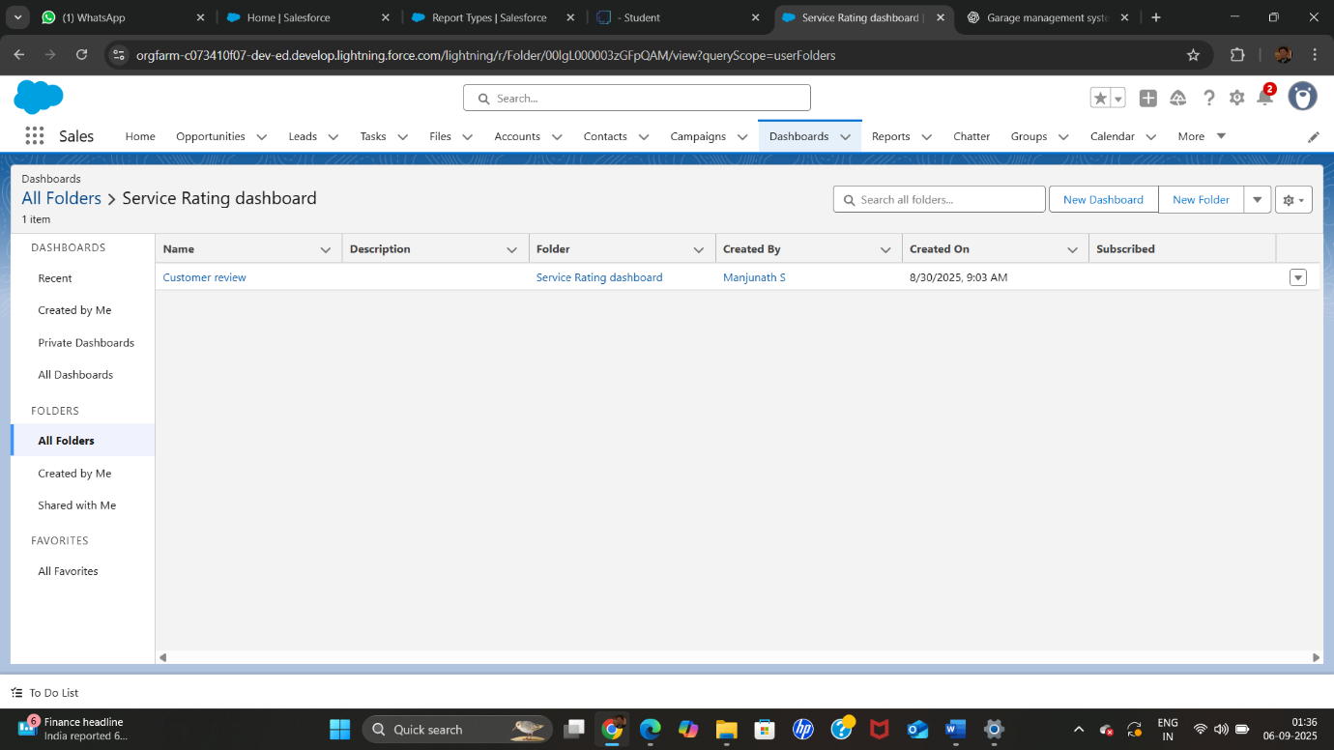

●FUNCTIONAL AND PERFORMANCE TESTING

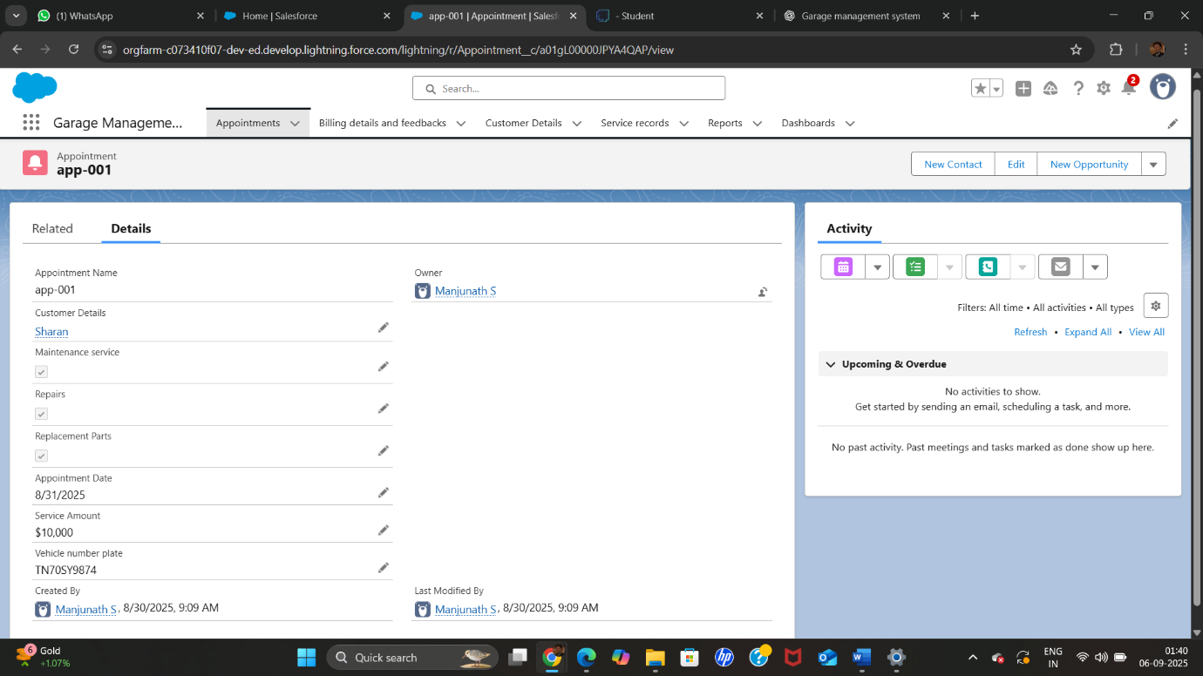

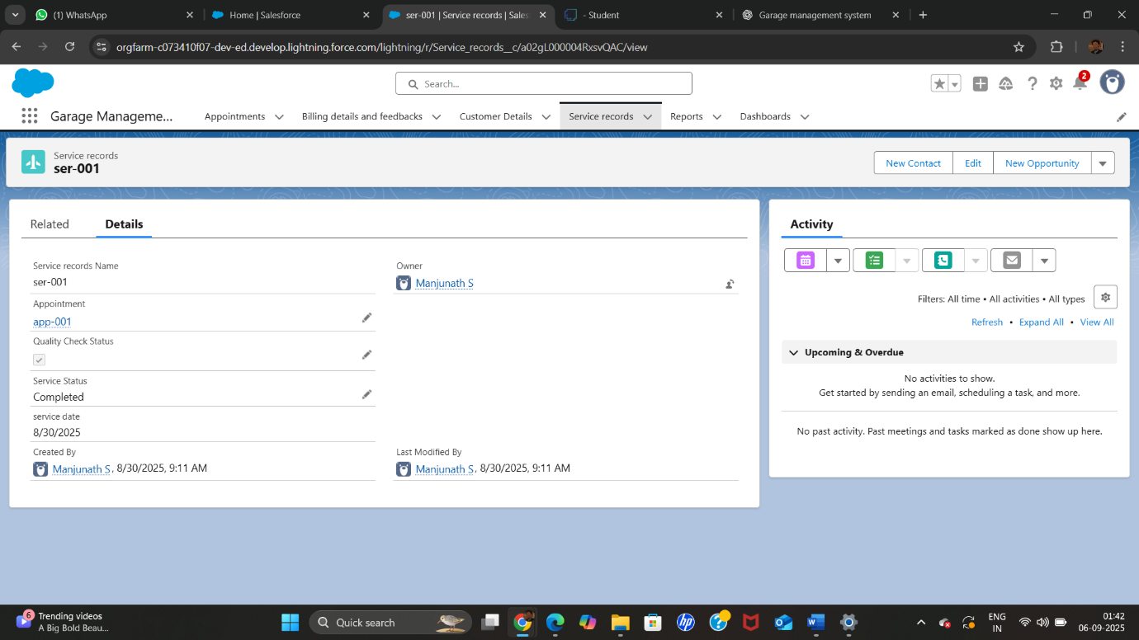

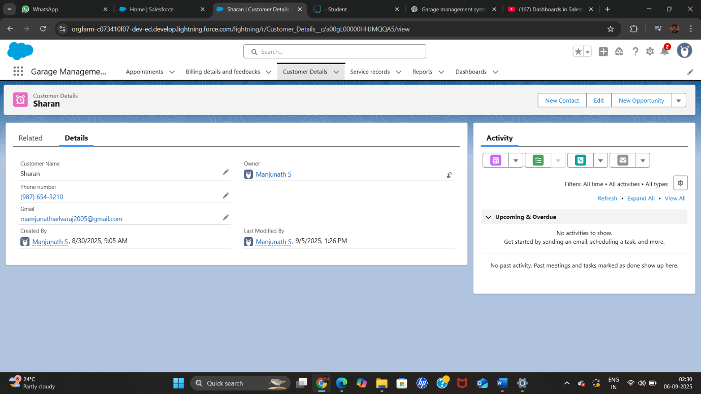

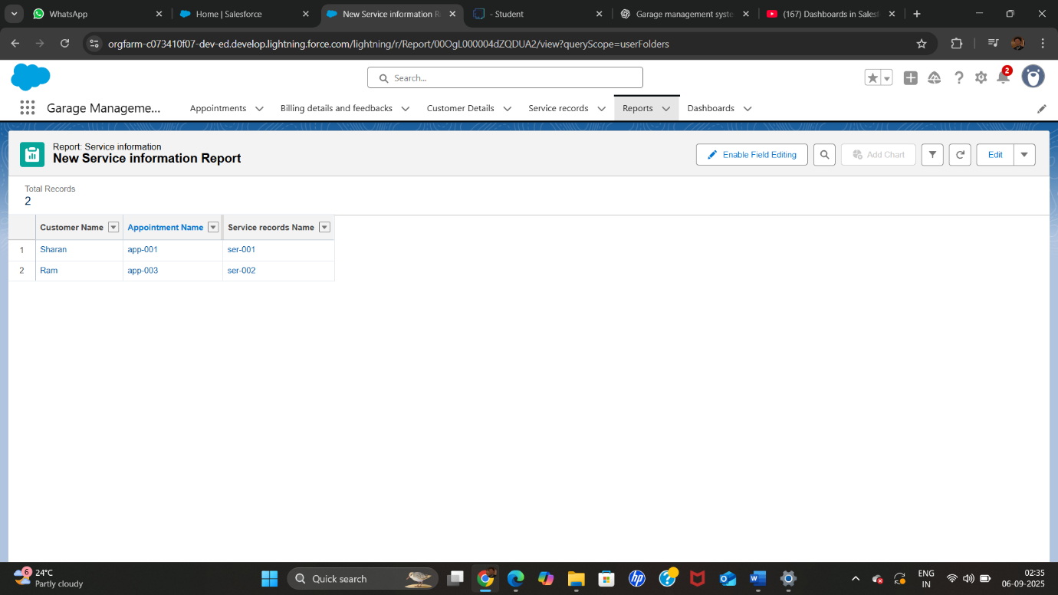

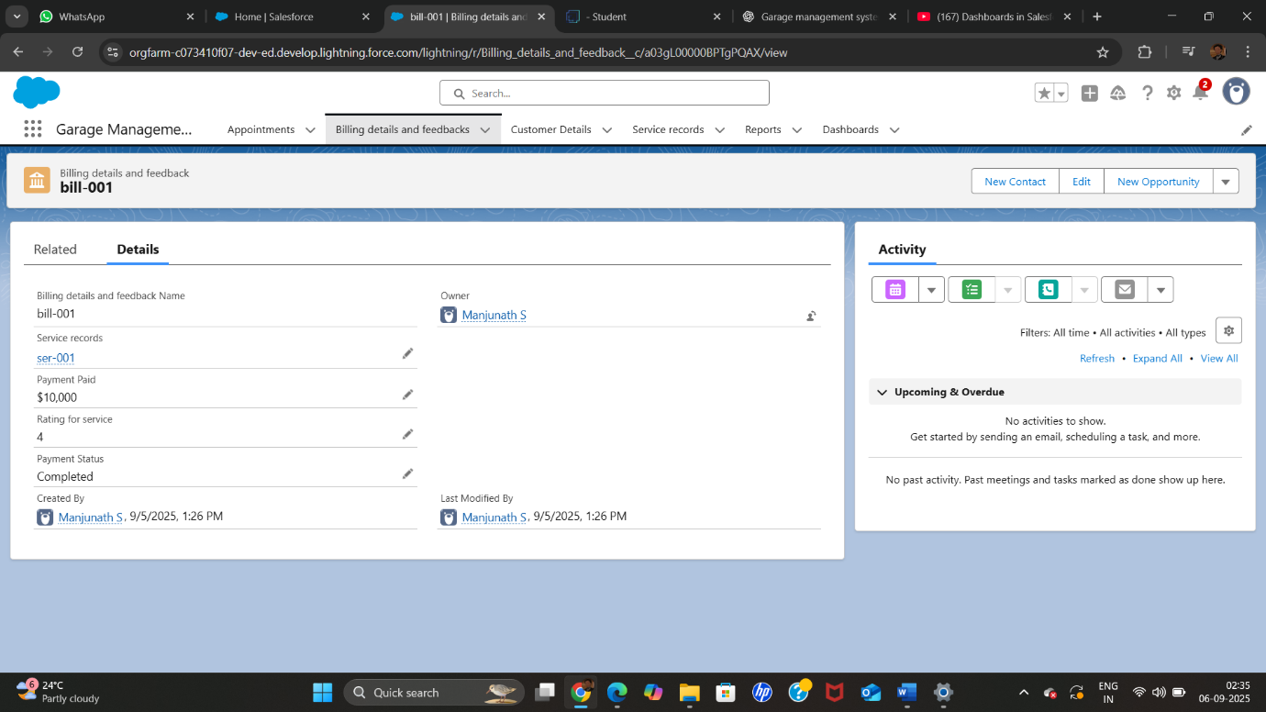

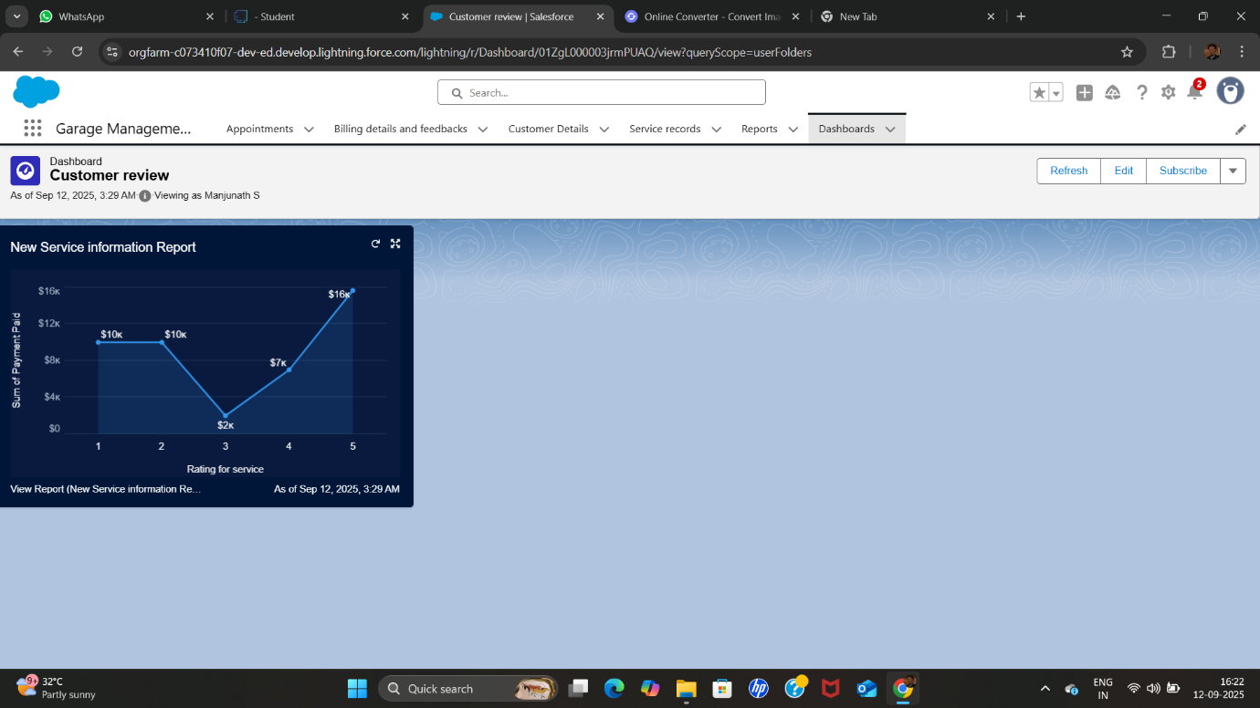

RESULTS

Output Screenshots

● Tabs for Customer Details, Appointments, Service records, Billing details and feedback

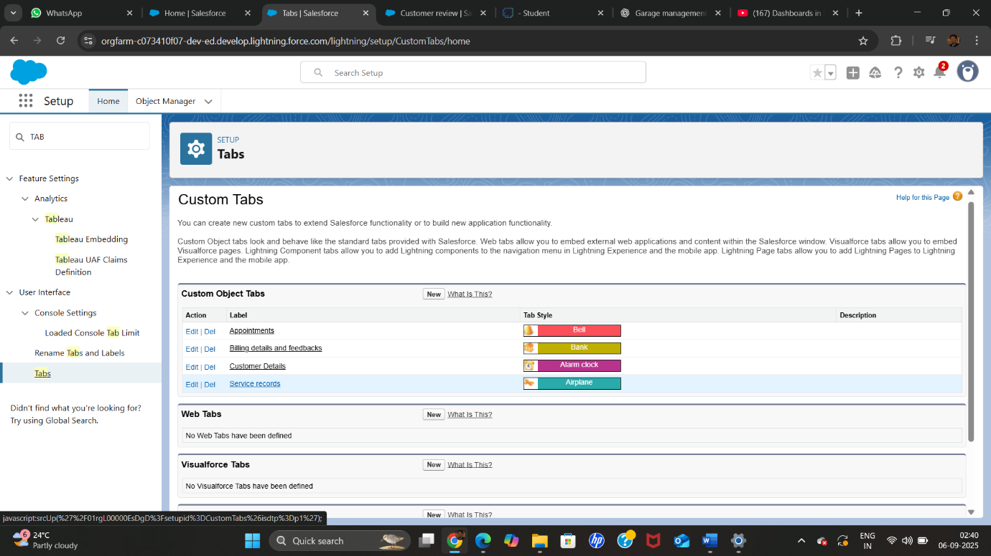

●Duplicate rule

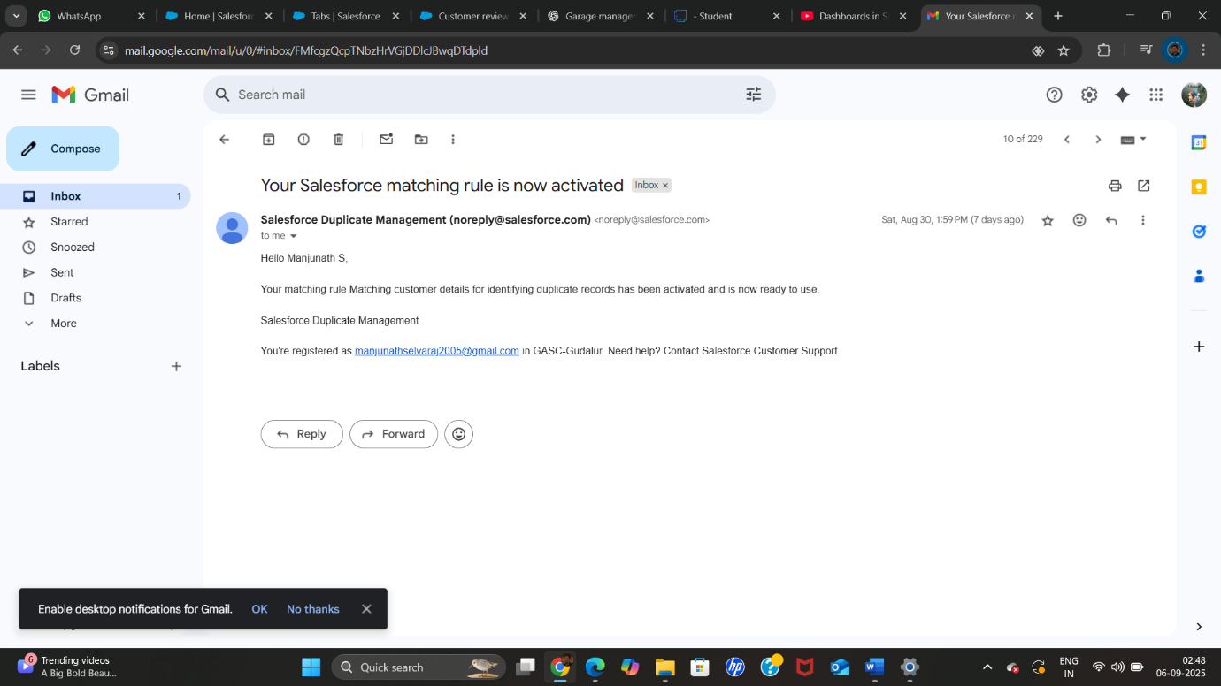

●Sharing Setting

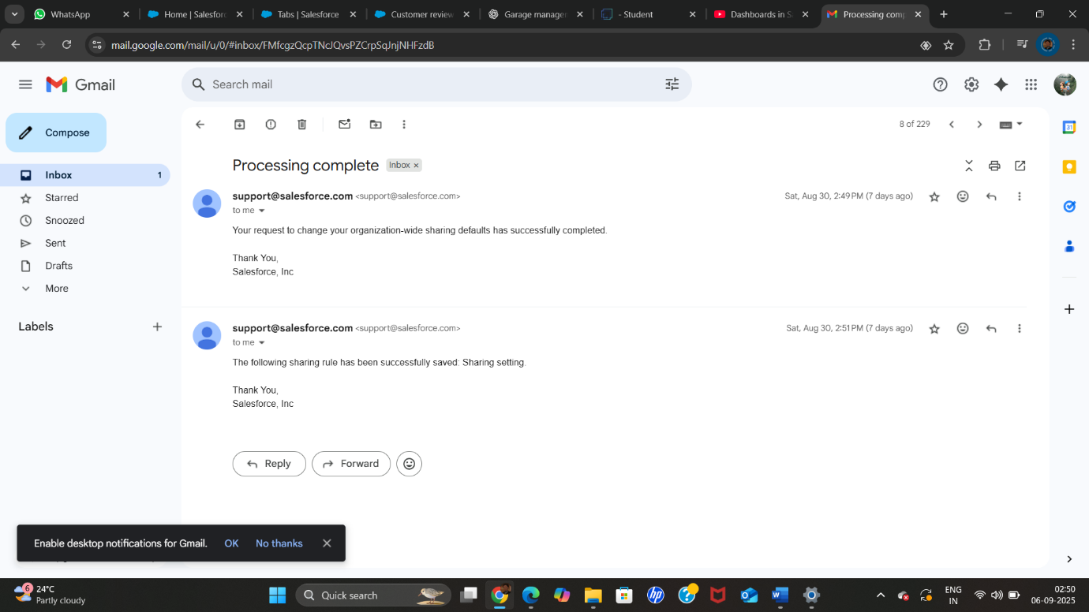

●FLOW RUNS 

● Trigger error messages

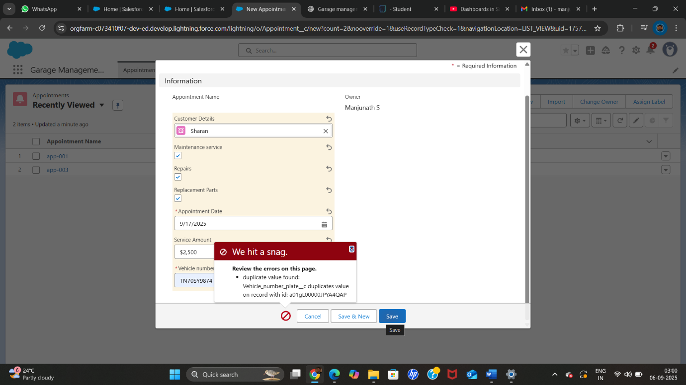

ADVANTAGES & DISADVANTAGES

Advantages

1. **Centralized Customer Management** – Stores and organizes customer details for quick access.
2. **Efficient Appointment Scheduling** – Reduces double-booking and improves time management.
3. **Accurate Service Records** – Keeps track of maintenance history for each vehicle.
4. **Simplified Billing** – Automates invoice generation, reduces calculation errors, and speeds up payments.
5. **Improved Customer Experience** – Feedback collection helps enhance service quality.
6. **Reports & Dashboards** – Provides insights into revenue, workload, and performance for better decision-making.
7. **Time & Cost Savings** – Minimizes paperwork and manual errors, improving overall productivity.
8. **Data Security** – Digital records are safer than physical files (with proper backups).

**Disadvantages**

1. **Initial Setup Cost** – Purchasing or developing the system can be expensive.
2. **Training Requirement** – Staff may need time and effort to learn the system.
3. **Technical Issues** – Downtime, bugs, or software crashes can disrupt operations.
4. **Data Security Risks** – If not properly secured, sensitive customer and billing data could be exposed.
5. **Dependency on Technology** – A power failure, internet issue, or system breakdown can halt operations.
6. **Maintenance Costs** – Regular updates, support, or subscription fees may be required.
7. **Resistance to Change** – Some employees may prefer manual methods and resist adopting the system.

CONCLUSION

The Garage Management System is an effective solution for simplifying and automating garage operations. By integrating customer details, appointments, service records, billing, feedback, and reporting into a single platform, the system enhances efficiency, accuracy, and customer satisfaction. It reduces manual workload, minimizes errors, and provides valuable insights for better decision-making through reports and dashboards.

Although challenges such as setup costs, training, and technical issues may arise, the long-term benefits outweigh these limitations. Overall, the Garage Management System is a modern, reliable, and efficient tool that supports both operational excellence and business growth in the automotive service industry.

APPENDIX

● Source Code: Provided in Apex Classes and Triggers

AmountDistributionHandler

Code:

public class AmountDistributionHandler {

    public static void amountDist(list<Appointment__c> listApp){

        list<Service_records__c> serList = new list <Service_records__c>();

        for(Appointment__c app : listApp){

            if(app.Maintenance_service__c == true && app.Repairs__c == true && app.Replacement_Parts__c == true){

                app.Service_Amount__c = 10000;

            }

            else if(app.Maintenance_service__c == true && app.Repairs__c == true){

                app.Service_Amount__c = 5000;

            }

            else if(app.Maintenance_service__c == true && app.Replacement_Parts__c == true){

                app.Service_Amount__c = 8000;

            }

            else if(app.Repairs__c == true && app.Replacement_Parts__c == true){

                app.Service_Amount__c = 7000;

            }

            else if(app.Maintenance_service__c == true){

                app.Service_Amount__c = 2000;

            }

            else if(app.Repairs__c == true){

                app.Service_Amount__c = 3000;

            }

            else if(app.Replacement_Parts__c == true){

                app.Service_Amount__c = 5000;

            }

    }

    }

}

AmountDistribution

Code:

trigger AmountDistribution on Appointment__c (before insert, before update) {

    if(trigger.isbefore && trigger.isinsert || trigger.isupdate){

        AmountDistributionHandler.amountDist(trigger.new);

    }

}